SUPPLY CHAIN ANALYSIS
Diagnostic Analysis Report
CDACL-003 – Supply Chain Analysis
Prepared using Microsoft Power BI

SOUNAPURAM KAVYA SHALINI
TEAM ID : PTID-CDA-SEP-26-11315

1. Introduction
This report presents a diagnostic analysis of the available supply chain data. The analysis covers product sales, revenue, inventory, manufacturing costs, supplier lead times, transportation costs, quality performance, and supplier revenue contribution. Microsoft Power BI was used to create the comparative dashboard.

2. Project Objectives
- Analyze revenue by product type.
- Compare products sold by product type.
- Analyze stock-level distribution.
- Compare average manufacturing costs.
- Evaluate supplier lead times.
- Compare shipping costs by transportation mode.
- Analyze defect rates by product type.
- Compare supplier revenue contribution.
- Develop a comparative Power BI dashboard.
- Provide diagnostic findings and recommendations.

3. Dataset Overview
The cleaned dataset used for the dashboard contains 100 records and 24 fields covering product, sales, inventory, supplier, manufacturing, shipping, transportation, and quality information.
Category | Details
Records | 100
Product types | Skincare, Haircare, Cosmetics
Suppliers | Supplier 1–Supplier 5
Sales | Price, Availability, Number of products sold, Revenue generated
Inventory | Stock levels, Lead times, Order quantities
Shipping | Shipping times, Shipping carriers, Shipping costs
Manufacturing | Production volumes, Manufacturing lead time, Manufacturing costs
Quality | Inspection results, Defect rates
Transportation | Transportation modes, Routes, Costs

4. Methodology
The cleaned data was loaded into Microsoft Power BI. Product type, supplier name, and transportation mode were used as comparison categories. Totals were used for revenue, products sold, stock levels, and shipping costs. Averages were used for manufacturing cost, supplier lead time, and defect rate.
- Data was cleaned and structured for analysis.
- Power BI was used for visualization.
- Three KPI cards were created.
- Eight comparative visuals were created.

5. KPI Cards
KPI | Value | Description
Total Revenue | 577.60K | Total revenue generated.
Total Products Sold | 46K | Total products sold.
Average Defect Rate | 2.28 | Average defect rate across the data.

6. Comparative Analysis
Skincare leads both revenue and products sold, making it the strongest product category in the displayed analysis.
Stock is comparatively balanced across the three product types.
Skincare has the highest average manufacturing cost, so its strong sales performance should be considered together with production cost.
Supplier 3 has the longest average lead time, while Supplier 1 has the shortest and also the highest revenue contribution.
Road has the highest total shipping cost, while Sea has the lowest in the displayed data.
Haircare has the highest average defect rate and should receive additional quality-control attention.

7. Diagnostic Findings
Area | Finding
Product performance | Skincare leads revenue and products sold.
Inventory | Stock is relatively balanced across product types.
Manufacturing | Skincare has the highest average manufacturing cost at 49.
Supplier lead time | Supplier 3 has the highest average lead time at 20.13.
Transportation | Road has the highest total shipping cost at 161; Sea has the lowest at 84.
Quality | Haircare has the highest average defect rate at approximately 2.48.
Supplier revenue | Supplier 1 has the highest revenue contribution at approximately 157.53K.

8. Recommendations
- Prioritize Skincare sales and inventory planning because it leads revenue and units sold.
- Monitor Skincare manufacturing costs because it has the highest average manufacturing cost.
- Investigate the higher Haircare defect rate and strengthen quality inspection and process controls.
- Monitor Supplier 3's lead time and investigate causes of longer supply cycles.
- Continue evaluating Supplier 1 as a strong supplier based on high revenue contribution and short average lead time.
- Evaluate transportation modes according to cost and delivery requirements.
- Maintain balanced inventory while ensuring high-demand Skincare products remain adequately stocked.
- Use the dashboard regularly to monitor revenue, sales, inventory, lead time, shipping cost, defects, and supplier contribution.

9. Dashboard Visuals

9.1 Revenue by product type
Visual used: Clustered Column Chart
Content:
This visual compares the total revenue generated by each product type. Skincare generates the highest revenue at approximately 242K, followed by Haircare at 174K and Cosmetics at 162K. This indicates that Skincare is the strongest revenue-generating product category.
Key takeaway: Skincare is the top-performing product category in terms of revenue.

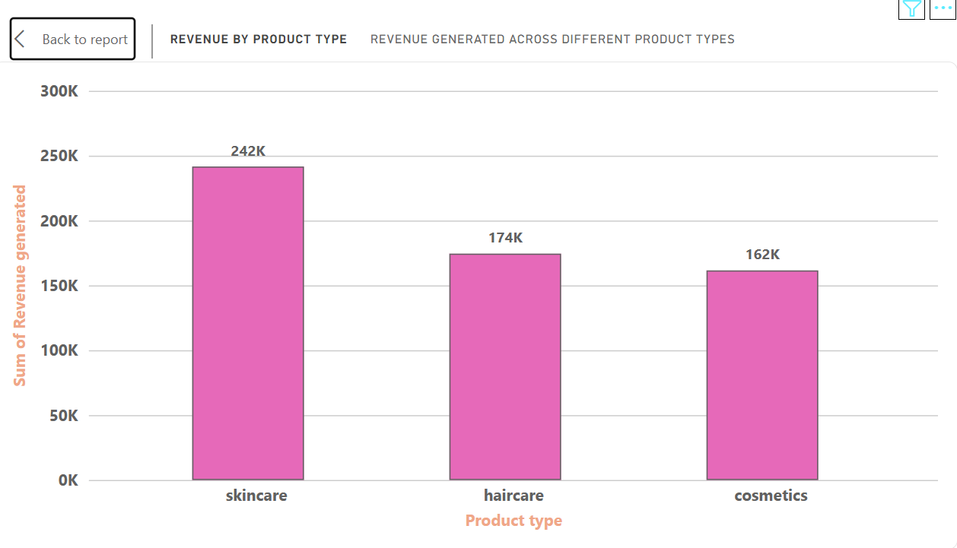
Figure 9.1: Revenue by product type

9.2 Products Sold by Product type
Visual used: Clustered Bar Chart
Content:
This chart compares the number of products sold across the three product categories. Skincare has the highest sales volume at approximately 20.7K, followed by Haircare at 13.6K and Cosmetics at 11.8K.
Key takeaway: Skincare has the highest demand based on products sold.

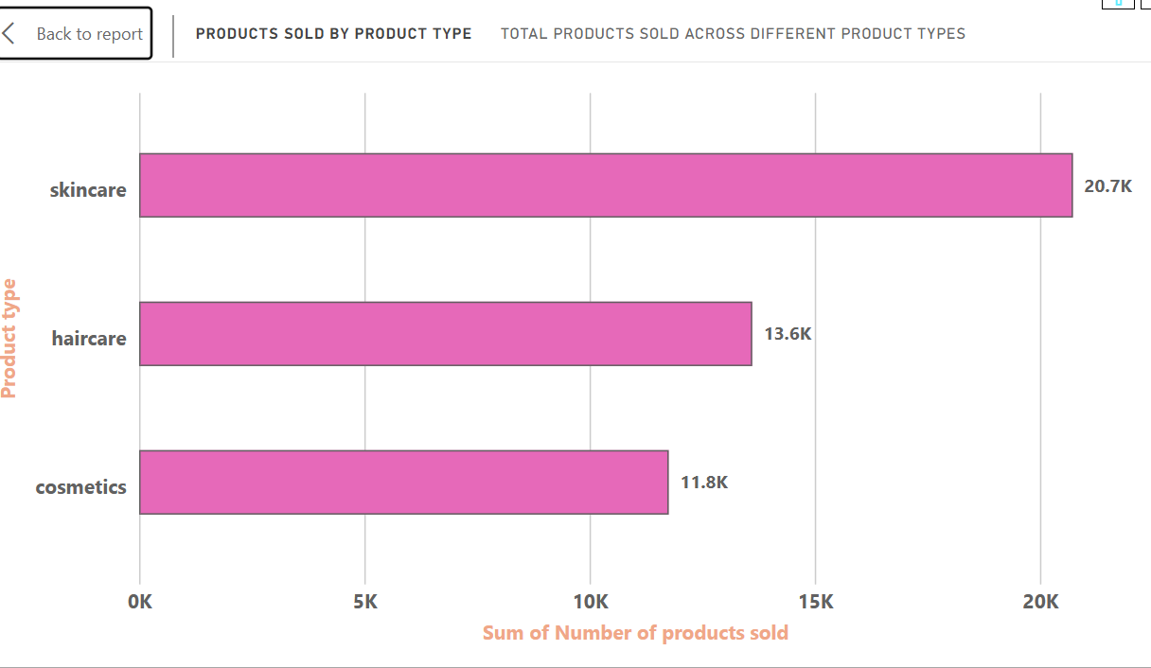
Figure 9.2: Products sold by Product type

9.3 Stock levels by Product type
Visual: Donut Chart
Content:
This visual shows how the available stock is distributed among the three product types. Haircare accounts for 34.41%, Skincare for 33.66%, and Cosmetics for 31.92% of the stock.
Key takeaway: Inventory is relatively balanced across all three product categories, with Haircare having the largest share.
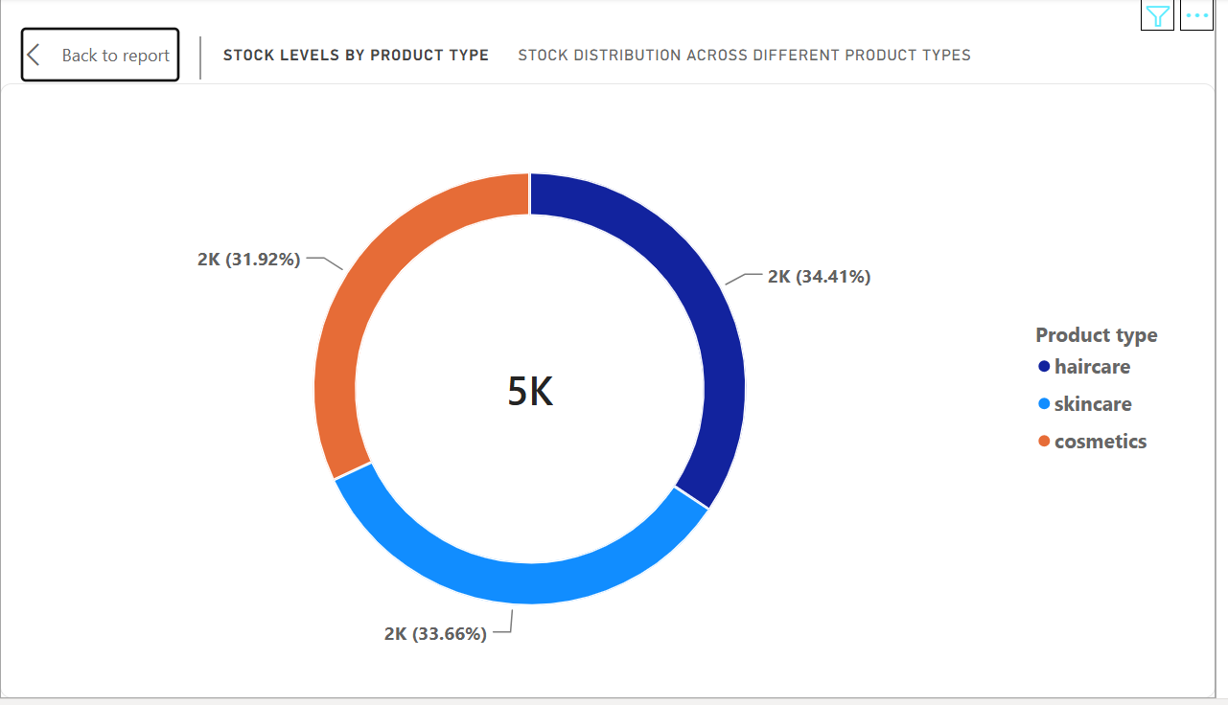
Figure 9.3: Stock levels by Product type

9.4 Average Manufacturing Cost
Visual: Clustered Column Chart
Content:
This chart compares the average manufacturing cost of each product type. Skincare has the highest average manufacturing cost at 49, followed by Haircare at 48 and Cosmetics at 43.
Key takeaway: Skincare has the highest production cost, so its strong revenue performance should be considered along with its manufacturing cost.
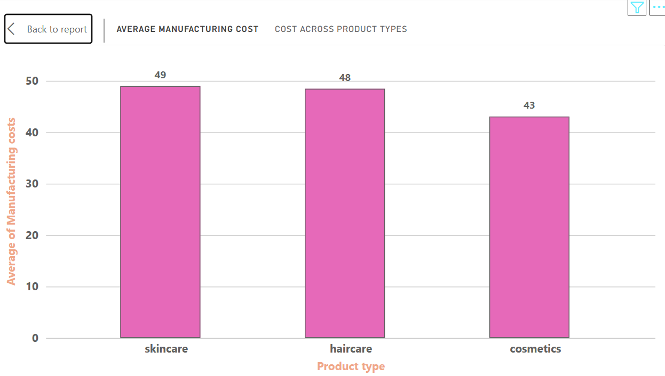
Figure 9.4: Average Manufacturing Cost

9.5 Average Lead Time by Supplier
Visual: Clustered Bar Chart
Content:
This visual compares the average lead time of the five suppliers. Supplier 3 has the longest average lead time at 20.13, while Supplier 1 has the shortest at 14.78.
Key takeaway: Supplier 3 may require closer monitoring because its longer lead time can affect supply efficiency.
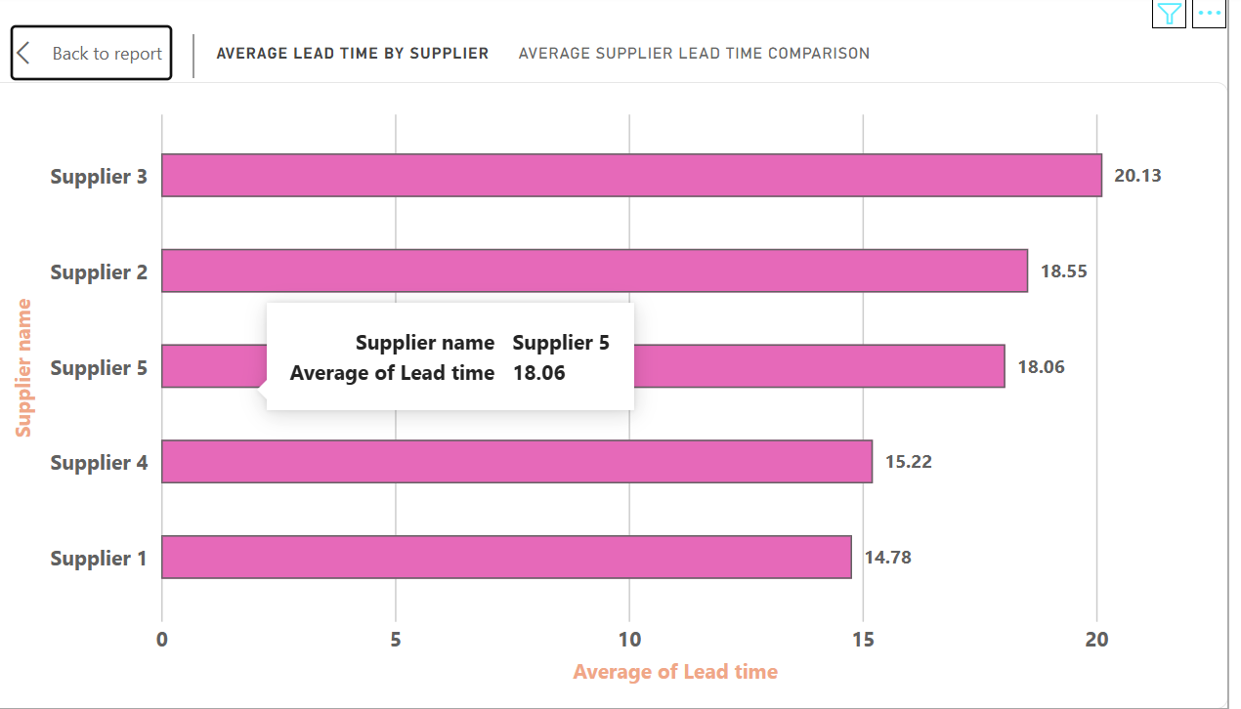
Figure 9.5: Average Lad Time by Supplier

9.6 Shipping Cost by Transportation Mode
Visual: Clustered Column Chart
Content:
This chart compares total shipping costs across different transportation modes. Road has the highest shipping cost at 161, followed by Air at 156 and Rail at 153. Sea has the lowest cost at 84.
Key takeaway: Sea transportation has the lowest shipping cost in the displayed data, while Road has the highest.
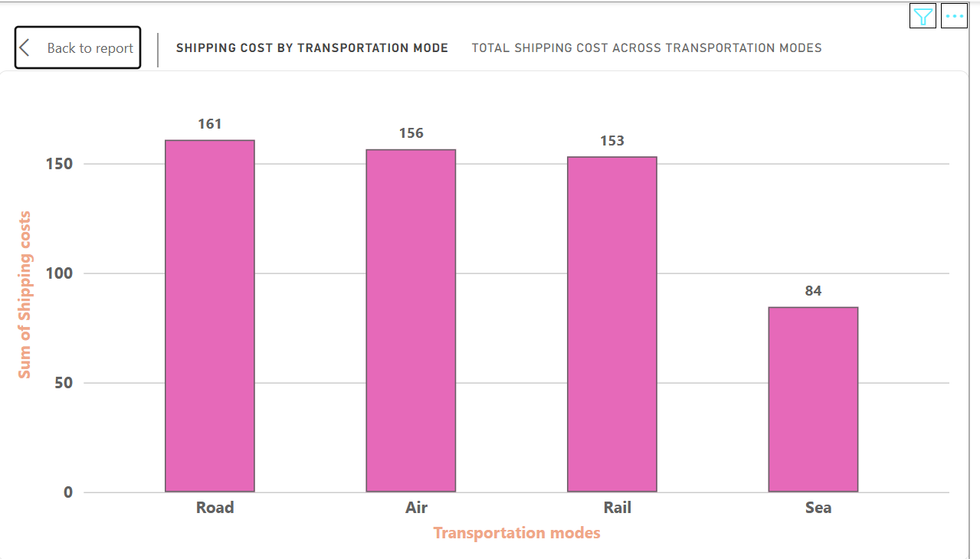
Figure 9.6: Shipping Cost by Transportation Mode

9.7 Defect Rate by Product Type
Visual: Donut Chart
Content:
This visual compares the average defect rate across product categories. Haircare has the highest average defect rate at approximately 2.48, followed by Skincare at 2.34 and Cosmetics at 1.92.
Key takeaway: Haircare requires additional quality-control attention to reduce defects.
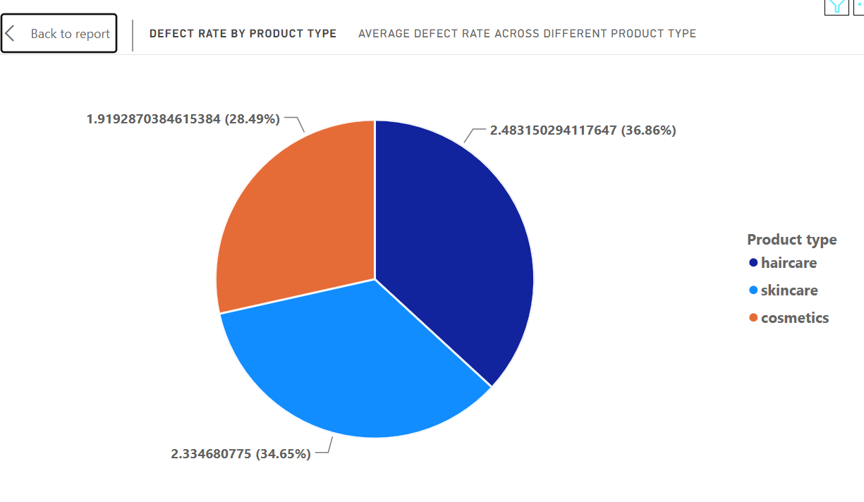
Figure 9.7: Defect Rate by Product Type

9.8 Revenue by Supplier
Visual: Tree map
Content:
This visual shows the contribution of each supplier to total revenue. Supplier 1 contributes the highest revenue at approximately 157.53K, followed by Supplier 2 at 125.47K and Supplier 5 at 110.34K. Supplier 4 has the lowest contribution at approximately 86.47K.
Key takeaway: Supplier 1 is the strongest supplier in terms of revenue contribution.
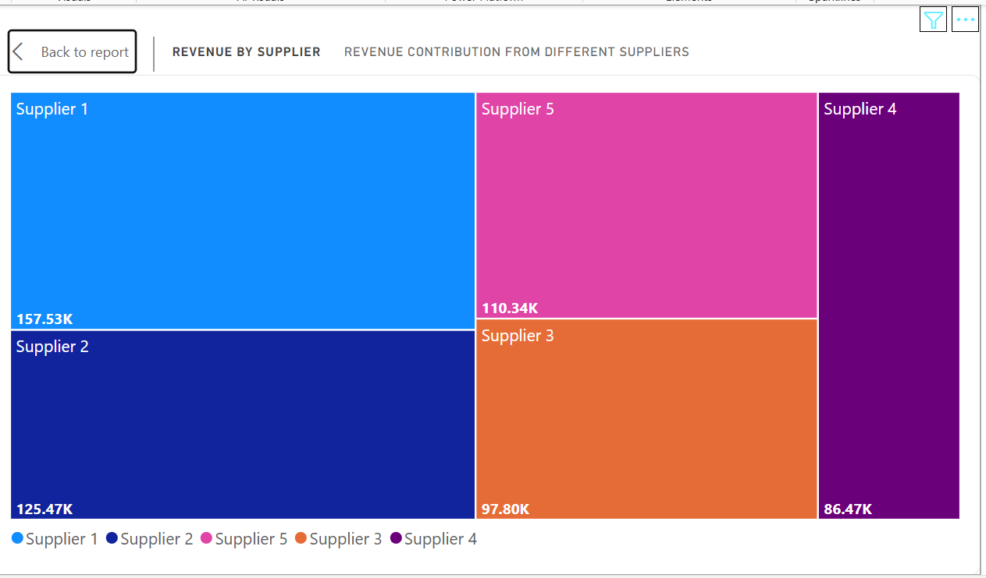
Figure 9.8: Revenue by Supplier

10. Supply Chain Analysis Dashboard
The completed Power BI dashboard combines the three KPI cards and eight supply chain visuals into one comparative management view.
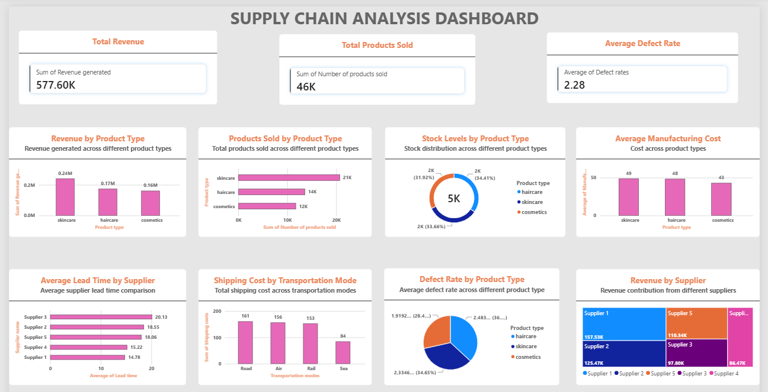
Figure 10. Completed Supply Chain Analysis Dashboard
The dashboard summarizes total revenue of 577.60K, total products sold of 46K, and an average defect rate of 2.28. It also provides product-level comparisons for revenue, sales, stock, manufacturing cost, supplier lead time, transportation shipping cost, defect rate, and supplier revenue.

11. Conclusion
The Supply Chain Analysis dashboard provides a consolidated view of product, supplier, manufacturing, transportation, inventory, and quality performance. Skincare is the leading product category in revenue and sales; Supplier 1 is the highest revenue-contributing supplier; Supplier 3 has the longest average lead time; Haircare has the highest average defect rate; and Road has the highest total shipping cost while Sea has the lowest in the displayed analysis.
These findings can support decisions related to product planning, supplier management, manufacturing cost control, transportation, inventory management, and quality improvement.

THE END

